PPG & Survey Results Report

Survey Results

MARCH 2014 GPAQ SURVEY
Number of Responses: 79
We would be grateful if you would complete this survey about your doctor and general practice. They want to provide the highest standard of care. A summary from this survey will be fed back to them to help them identify areas for improvement. Your opinions are very valuable. Please answer ALL the questions you can. There are no right or wrong answers and your doctor will NOT be able to identify your individual answers. Thank you.

About Your Visit to the GP

How good was the GP at
Q1 Putting you at ease?
Very good 86%
Good 10%
Satisfactory 1%
Poor 0%
Very poor 0%
Does not apply 0%
No response 3%
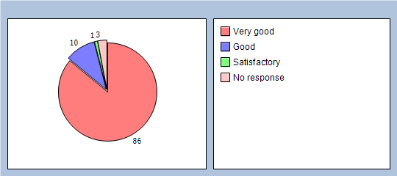
Q2 Being polite and considerate?
Very good 91%
Good 5%
Satisfactory 1%
Poor 0%
Very poor 0%
Does not apply 0%
No response 3%
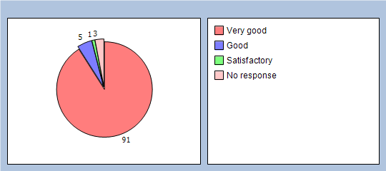
Q3 Listening to you?
Very good 83%
Good 12%
Satisfactory 1%
Poor 0%
Very poor 0%
Does not apply 0%
No response 4%
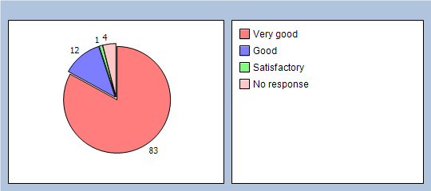
Q4 Giving you enough time?
Very good 78%
Good 15%
Satisfactory 2%
Poor 0%
Very poor 0%
Does not apply 1%
No response 4%
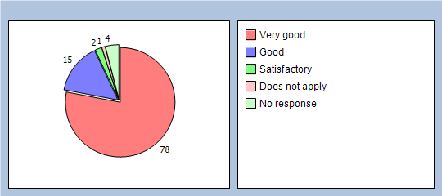
Q5 Assessing your medical condition?
Very good 75%
Good 8%
Satisfactory 6%
Poor 0%
Very poor 0%
Does not apply 3%
No response 8%
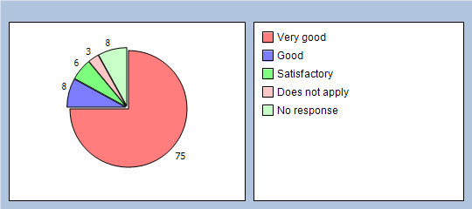

How good was the GP at:
Q6 Explaining your condition and treatment?
Very good 65%
Good 17%
Satisfactory 5%
Poor 1%
Very poor 0%
Does not apply 6%
No response 6%
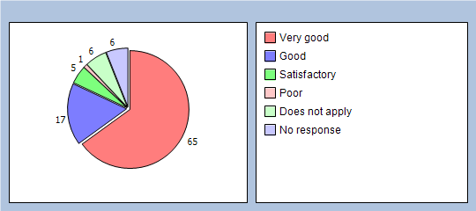
Q7 Involving you in decisions about your care?
Very good 67%
Good 17%
Satisfactory 2%
Poor 1%
Very poor 0%
Does not apply 7%
No response 6%
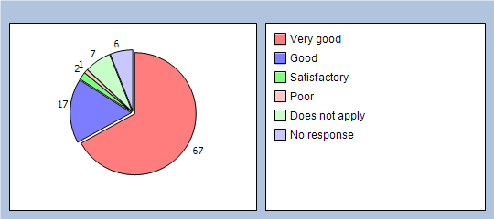
Q8 Providing or arranging treatment for you?
Very good 70%
Good 10%
Satisfactory 2%
Poor 2%
Very poor 0%
Does not apply 11%
No response 5%
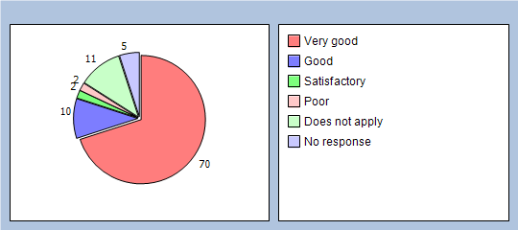
Q9 Did you have confidence that the GP is honest and trustworthy?
Yes, definitely 86%
Yes, to some extent 5%
No, not at all 0%
Don’t know / can’t say 1%
No response 8%
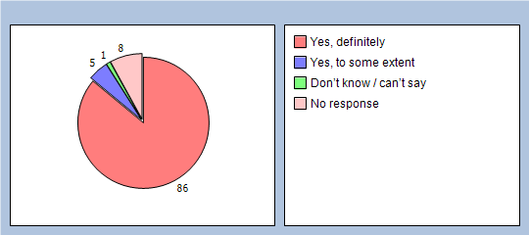
Q10 Did you have confidence that the doctor will keep your information confidential?
Yes, definitely 86%
Yes, to some extent 5%
No, not at all 0%
Don’t know / can’t say 3%
No response 6%
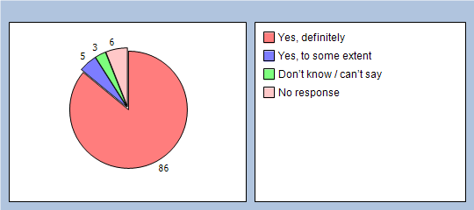
Q11 Would you be completely happy to see this GP again?
Yes 93%
No 1%
No response 6%
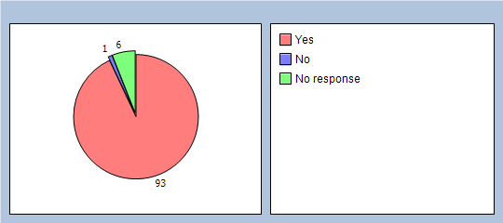
Please enter the name of the GP/Nurse you recently saw and add any additional comments:

About Receptionists and Appointments
Q12 How helpful do you find the receptionists at your GP practice?
Very helpful 86%
Fairly helpful 8%
Not very helpful 1%
Not at all helpful 0%
Don’t know 0%
No response 5%
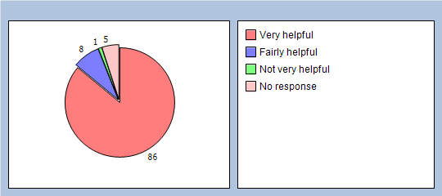
Q13 How easy is it to get through to someone at your GP practice on the phone?
Very easy 51%
Fairly easy 29%
Not very easy 10%
Not at all easy 3%
Don’t know 0%
Haven’t tried 0%
No response 7%
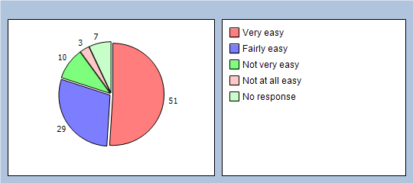
Q14 How easy is it to speak to a doctor or nurse on the phone at your GP practice?
Very easy 37%
Fairly easy 27%
Not very easy 8%
Not at all easy 1%
Don’t know 2%
Haven’t tried 15%
No response 10%
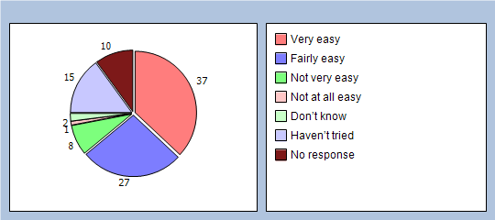
Q15 If you need to see a GP urgently, can you normally get seen on the same day?
Yes 67%
No 6%
Don’t know / never needed to 18%
No response 9%
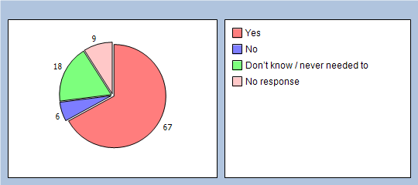
Q16 How important is it to you to be able to book appointments ahead of time in your practice?
Important 75%
Not important 16%
No response 9%
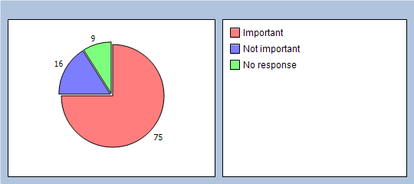
Q17 How easy is it to book ahead in your practice?
Very easy 49%
Fairly easy 30%
Not very easy 3%
Not at all easy 2%
Don’t know 1%
Haven’t tried 5%
No response 10%
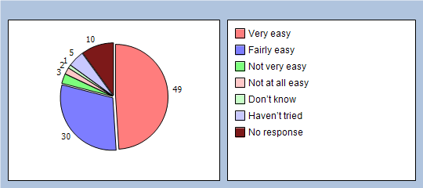
Q18 How do you normally book your appointments at your practice? (please X all boxes that apply)
In person 29%
By phone 81%
Online 0%
Doesn’t apply 0%
Q19 Which of the following methods would you prefer to use to book appointments at your practice? (please X all boxes that apply)
In person 30%
By phone 79%
Online 11%
Doesn’t apply 1%

Thinking of times when you want to see a particular doctor:
Q20 How quickly do you usually get seen?
Same day or next day 41%
2-4 days 18%
5 days or more 13%
I don’t usually need to be seen quickly 10%
Don’t know, never tried 10%
No response 8%
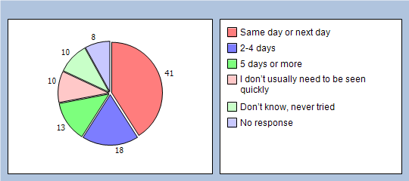
Q21 How do you rate how quickly you were seen?
Excellent 41%
Very good 15%
Good 13%
Satisfactory 7%
Poor 2%
Very poor 0%
Does not apply 10%
No response 12%
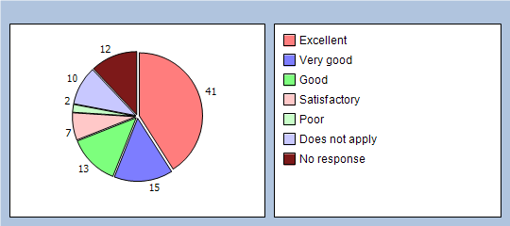

Thinking of times when you are willing to see any doctor:
Q22 How quickly do you usually get seen?
Same day or next day 72%
2-4 days 7%
5 days or more 0%
I don’t usually need to be seen quickly 5%
Don’t know, never tried 8%
No response 8%
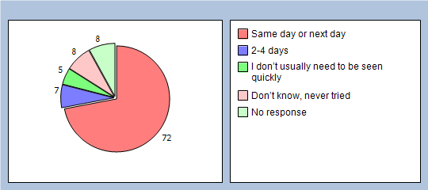
Q23 How do you rate how quickly you were seen?
Excellent 51%
Very good 22%
Good 5%
Satisfactory 2%
Poor 1%
Very poor 0%
Does not apply 10%
No response 9%
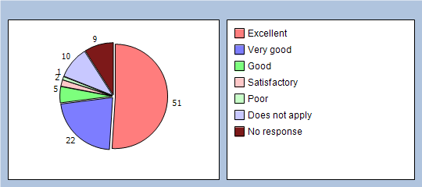

Thinking of your most recent consultation with a doctor or nurse
Q24 How long did you wait for your consultation to start?
Less than 5 minutes 45%
5 – 10 minutes 35%
11 – 20 minutes 13%
21 – 30 minutes 0%
More than 30 minutes 0%
There was no set time for my consultation 1%
No response 6%
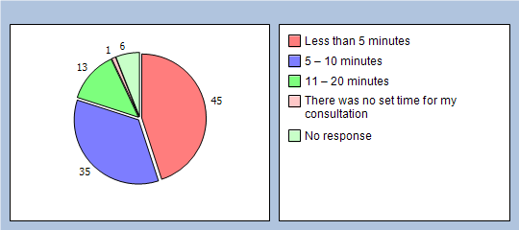
Q25 How do you rate how long you waited?
Excellent 50%
Very good 22%
Good 13%
Satisfactory 7%
Poor 0%
Very poor 0%
Does not apply 0%
No response 8%
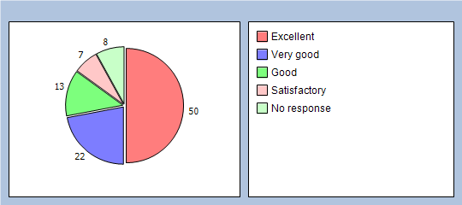
Q26 Is your GP practice currently open at times that are convenient to you?
Yes (Go to Q28) 84%
No 5%
Don’t know 5%
No response 6%
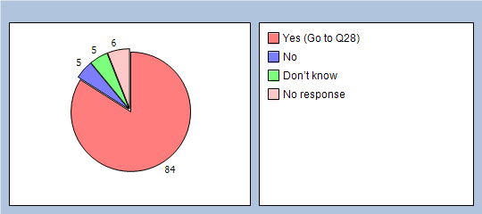
Q27 Which of the following additional opening hours would make it easier for you to see or speak to someone? (please X all boxes that apply)
Before 8am 10%
At lunchtime 6%
After 6.30pm 12%
On a Saturday 16%
On a Sunday 3%
None of these 13%
Q28 Is there a particular GP you usually prefer to see or speak to?
Yes 68%
No (Go to Q30) 24%
There is usually only one doctor in my surgery (Go to Q30) 0%
No response 8%
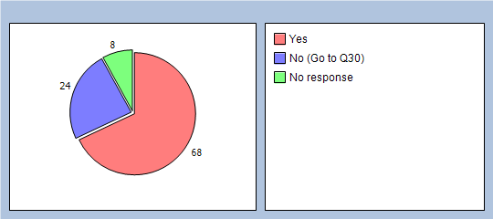
Q29 How often do you see or speak to the GP you prefer?
Always or almost always 31%
A lot of the time 17%
Some of the time 11%
Never or almost never 1%
Not tried at this GP practice 11%
No response 29%
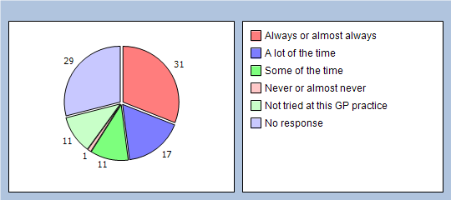

If you haven’t seen a nurse in the last 6 months please go to Q37. How good was the Nurse you last saw at:
Q30 Putting you at ease?
Very good 75%
Good 11%
Satisfactory 2%
Poor 0%
Very poor 0%
Does not apply 0%
No response 12%
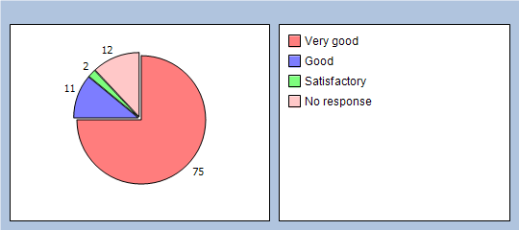
Q31 Giving you enough time?
Very good 68%
Good 17%
Satisfactory 2%
Poor 0%
Very poor 0%
Does not apply 1%
No response 12%
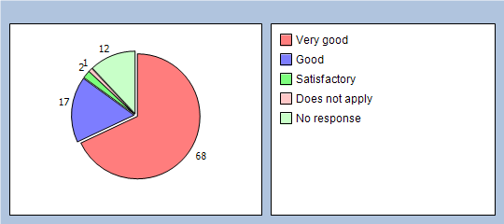
Q32 Listening to you?
Very good 73%
Good 13%
Satisfactory 1%
Poor 0%
Very poor 0%
Does not apply 0%
No response 13%
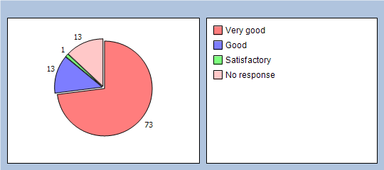
Q33 Explaining your condition and treatment?
Very good 68%
Good 15%
Satisfactory 3%
Poor 0%
Very poor 0%
Does not apply 1%
No response 13%
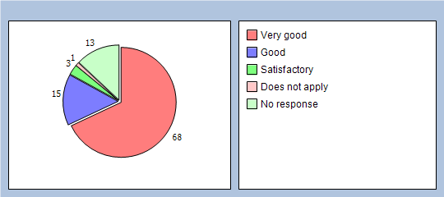
Q34 Involving you in decisions about your care?
Very good 65%
Good 15%
Satisfactory 5%
Poor 0%
Very poor 0%
Does not apply 3%
No response 12%
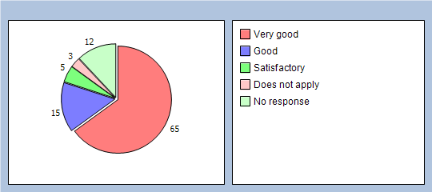
Q35 Providing or arranging treatment for you?
Very good 65%
Good 10%
Satisfactory 2%
Poor 0%
Very poor 1%
Does not apply 7%
No response 15%
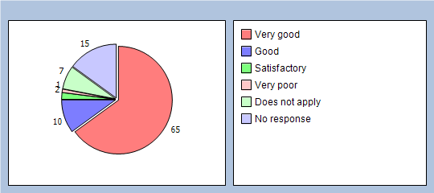
Q36 Would you be completely happy to see this nurse again?
Yes 87%
No 0%
No response 13%
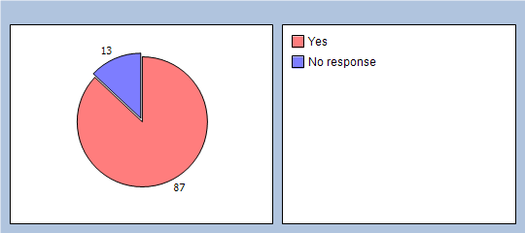

Thinking about the care you get from your doctors and nurses overall, how well does the practice help you to:
Q37 Understand your health problems?
Very well 81%
Unsure 11%
Not very well 1%
Does not apply 2%
No response 5%
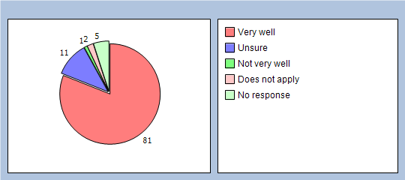
Q38 Cope with your health problems
Very well 75%
Unsure 15%
Not very well 1%
Does not apply 3%
No response 6%
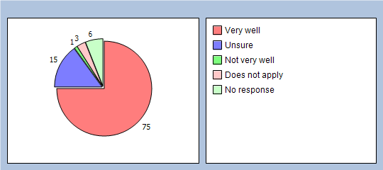
Q39 Keep yourself healthy
Very well 70%
Unsure 17%
Not very well 1%
Does not apply 5%
No response 7%
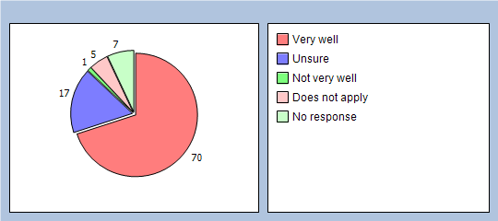
Q40 Overall, how would you describe your experience of your GP surgery?
Excellent 63%
Very good 24%
Good 6%
Satisfactory 1%
Poor 0%
Very poor 0%
No response 6%
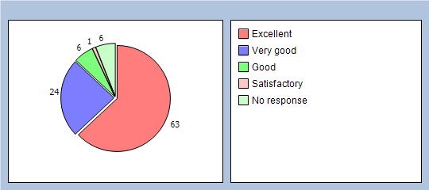
Q41 Would you recommend your GP surgery to someone who has just moved to your local area?
Yes, definitely 77%
Yes, probably 18%
No, probably not 0%
No, definitely not 0%
Don’t know 0%
No response 5%
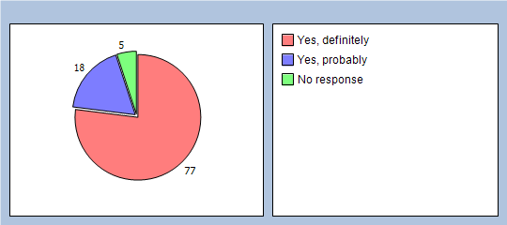

It will help us to understand your answers if you could tell us a little about yourself
Q42 Are you ?
Male 35%
Female 59%
No response 6%
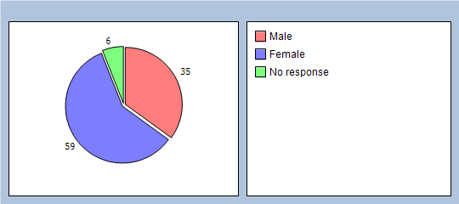
Q43 How old are you?
Under 16 2%
16 to 44 17%
45 to 64 34%
65 to 74 26%
75 or over 13%
No response 8%
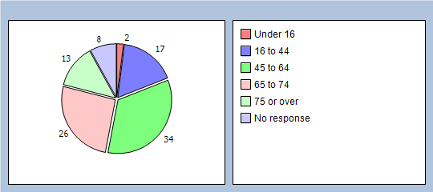
Q44 Do you have a long-standing health condition?
Yes 63%
No 26%
Don’t know / can’t say 3%
No response 8%
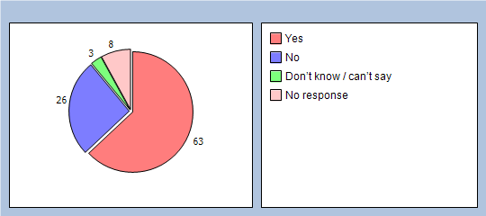
Q45 What is your ethnic group?
White 91%
Black or Black British 0%
Asian or Asian British 0%
Mixed 2%
Chinese 0%
Other ethnic group 0%
No response 7%
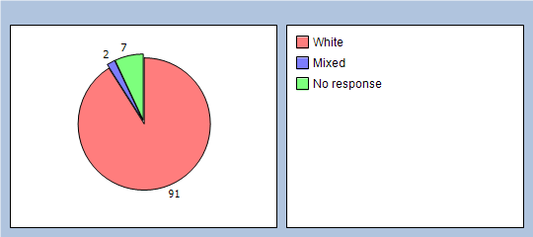
Q46 Which of the following best describes you?
Employed (full or part time, including self-employed) 31%
Unemployed / looking for work 1%
At school or in full time education 2%
Unable to work due to long term sickness 3%
Looking after your home/family 6%
Retired from paid work 48%
Other 1%
No response 8%
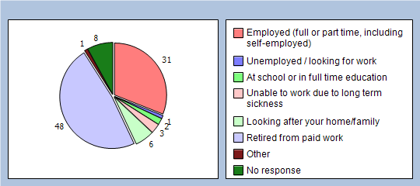
Finally, please add any other comments you would like to make about your GP practice:
GPAQ-R © 2013 is reproduced with the kind permission of the University of Manchester & University of Cambridge. GPAQ incorporates the Primary Care Assessment Survey (PCAS); with permission from Dr Dana Gelb Safran creator of PCAS. www.gpaq.info

Neetside Surgery Patient Survey Nov 2012
Number of Responses: 62
We would be grateful if you would complete this survey about your general practice. Your doctors want to provide the highest standard of care. Feedback from this survey will help them to identify areas that may need improvement. Your opinions are very valuable.
Please answer ALL the questions that apply to you. There are no right or wrong answers and your doctor will NOT be able to identify your individual answers.
Thank you.

About Receptionists and Appointments
Q1 How helpful do you find the receptionists at your GP practice?
Very helpful 83%
Fairly helpful 11%
Not very helpful 1%
Not at all helpful 0%
Don’t know 3%
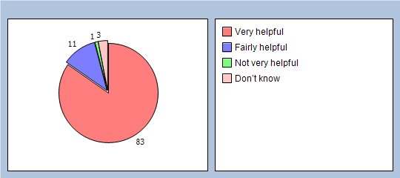
Q2 How easy is it to get through to someone at your GP practice on the phone?
Very easy 43%
Fairly easy 27%
Not very easy 19%
Not at all easy 3%
Don’t know 0%
Haven’t tried 6%
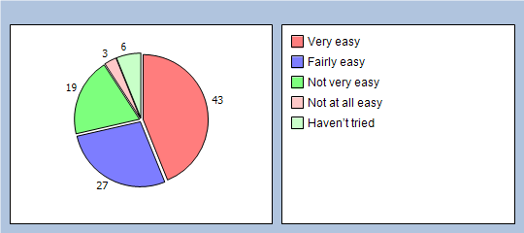
Q3 How easy is it to speak to a doctor or nurse on the phone at your GP practice?
Very easy 32%
Fairly easy 30%
Not very easy 8%
Not at all easy 1%
Don’t know 3%
Haven’t tried 22%
No response 4%
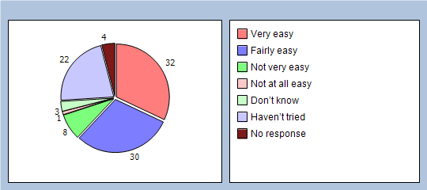
Q4 If you need to see a GP urgently, can you normally get seen on the same day?
Yes 67%
No 6%
Don’t know / never needed to 24%
No response 3%
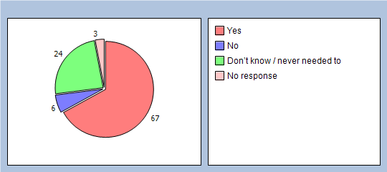
Q5 How important is it to you to be able to book appointments ahead of time in your practice?
Important 74%
Not important 24%
No response 2%
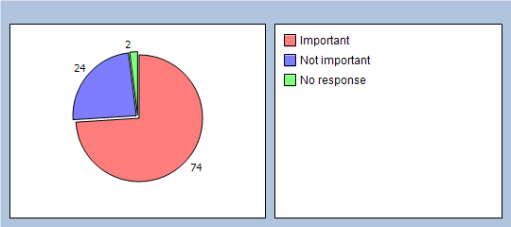

Do you realise you can book 4 weeks in advance
Q6 How easy is it to book ahead in your practice?
Very easy 37%
Fairly easy 20%
Not very easy 8%
Not at all easy 0%
Don’t know 11%
Haven’t tried 22%
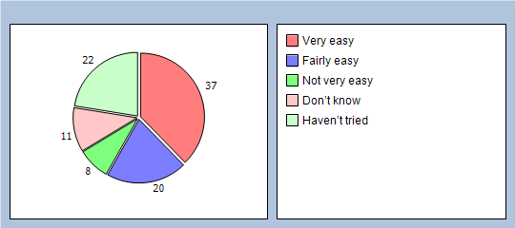
Q7 How do you normally book your appointments at your practice? Please tick all boxes that apply.
In person 41%
By phone 80%
Doesn’t apply 3%
Q8 Which of the following methods would you prefer to use to book appointments at your practice? Please tick all boxes that apply.
In person 38%
By phone 75%
Online 29%
Doesn’t apply 3%

Thinking of times when you want to see a particular doctor:
Q9 How quickly do you usually get seen?
Same day or next day 40%
2-4 days 30%
5 days or more 4%
I don’t usually need to be seen quickly 16%
Don’t know, never tried 8%
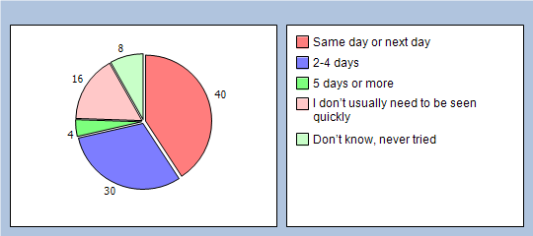
Q10 How do you rate this?
Excellent 35%
Very good 22%
Good 9%
Fair 8%
Poor 3%
Very poor 1%
Does not apply 17%
No response 5%
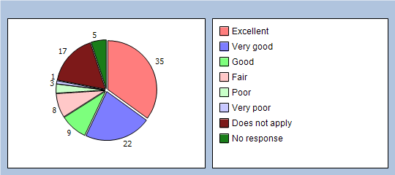

Thinking of times when you are willing to see any doctor:
Q11 How quickly do you usually get seen?
Same day or next day 56%
2-4 days 24%
5 days or more 3%
I don’t usually need to be seen quickly 11%
Don’t know, never tried 4%
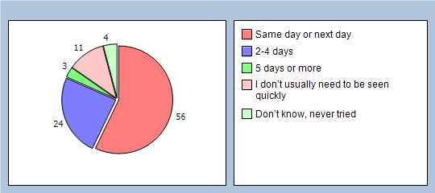
Q12 How do you rate this?
Excellent 37%
Very good 25%
Good 12%
Fair 4%
Poor 1%
Very poor 1%
Does not apply 14%
No response 6%
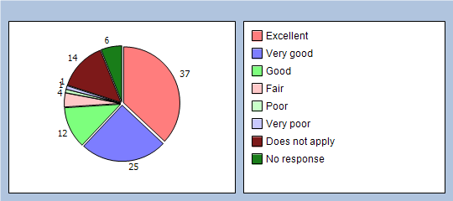
Q13 When you telephone for an urgent appointment are you sataisfied with the way in which the nurse assesses your needs.
Exellent 30%
Very good 27%
Good 9%
Fair 9%
Poor 1%
Very poor 0%
Does not apply 19%
No response 5%
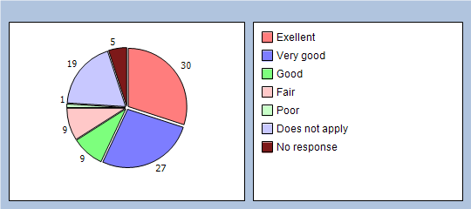

Thinking of your most recent consultation with a doctor or nurse
Q14 How long did you wait for your consultation to start?
Less than 5 minutes 29%
5 – 10 minutes 45%
11 – 20 minutes 17%
21 – 30 minutes 1%
More than 30 minutes 3%
There was no set time for my consultation 1%
No response 4%
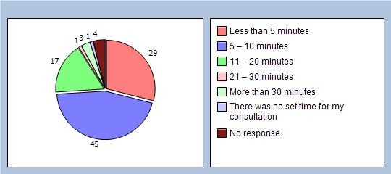
Q15 How do you rate this?
Excellent 37%
Very good 27%
Good 20%
Fair 6%
Poor 1%
Very poor 0%
Does not apply 1%
No response 8%
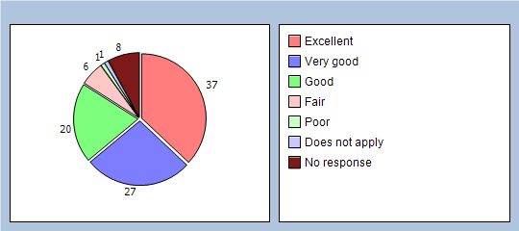

About opening times
Q16 Have you ever been unable to see a GP due to the opening times
Yes - Go to Q17 17%
No 75%
Don’t know 4%
No response 4%
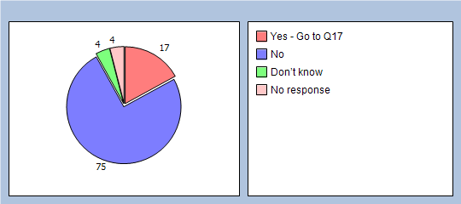
About seeing the doctor of your choice
Q17 Is there a particular GP you usually prefer to see or speak to?
Yes 64%
No - Go to Q19 35%
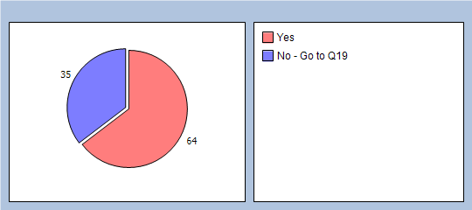
Q18 How often do you see or speak to the GP you prefer?
Always or almost always 32%
A lot of the time 20%
Some of the time 4%
Never or almost never 4%
Not tried at this GP practice 3%
No response 37%
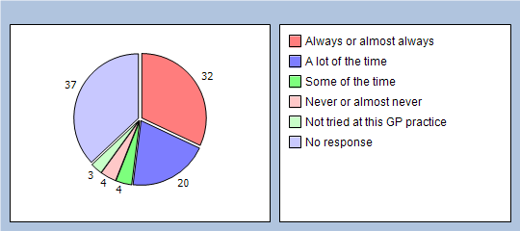

How good was the last GP you saw at each of the following?
(If you haven’t seen a GP in your practice in the last 6 months, please go to Q25)
Q19 Giving you enough time
Very good 62%
Good 20%
Fair 11%
Poor 0%
Very poor 0%
Does not apply 0%
No response 7%
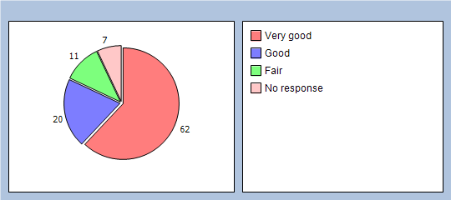
Q20 Listening to you
Very good 72%
Good 16%
Fair 6%
Poor 0%
Very poor 0%
Does not apply 0%
No response 6%
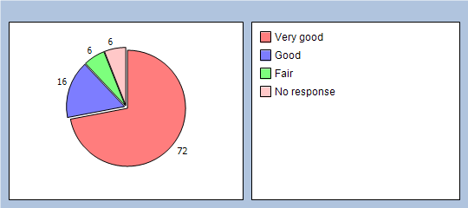
Q21 Explaining tests and treatments
Very good 66%
Good 20%
Fair 4%
Poor 1%
Very poor 0%
Does not apply 1%
No response 8%
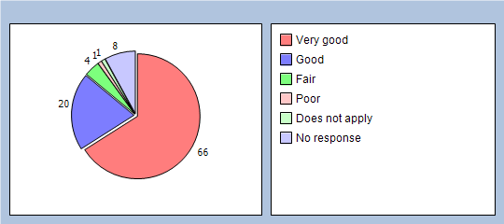
Q22 Involving you in decisions about your care
Very good 69%
Good 12%
Fair 8%
Poor 0%
Very poor 1%
Does not apply 3%
No response 7%
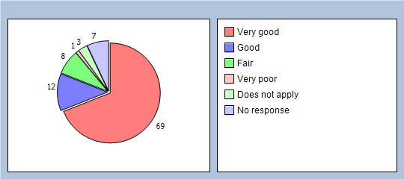
Q23 Treating you with care and concern
Very good 74%
Good 16%
Fair 3%
Poor 1%
Very poor 0%
Does not apply 0%
No response 6%
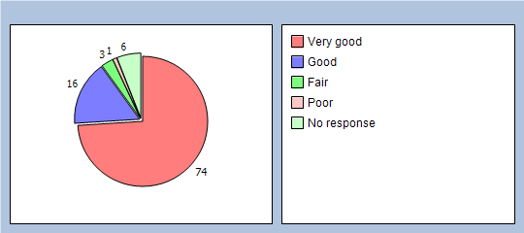
Q24 Did you have confidence and trust in the GP you saw or spoke to?
Yes, definitely 80%
Yes, to some extent 9%
No, not at all 0%
Don’t know / can’t say 4%
No response 7%
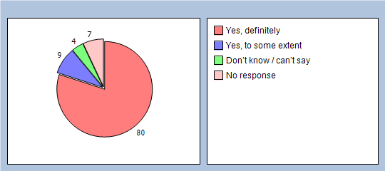
If you know the name of the GP you last saw, please write it here:

How good was the last nurse you saw at each of the following?
(If you haven’t seen a nurse in your practice in the last 6 months, please go to Q31)
Q25 Giving you enough time
Very good 66%
Good 11%
Fair 1%
Poor 0%
Very poor 0%
Does not apply 4%
No response 18%
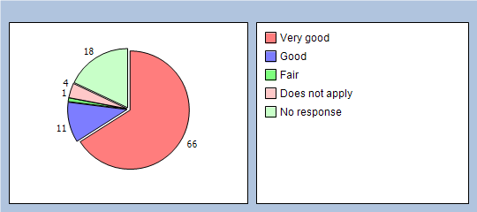
Q26 Listening to you
Very good 64%
Good 11%
Fair 4%
Poor 0%
Very poor 0%
Does not apply 1%
No response 20%
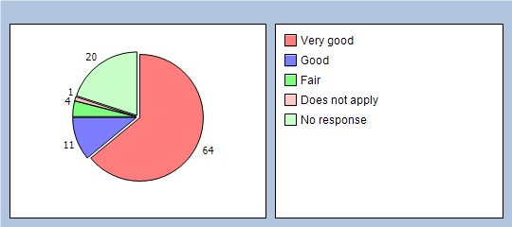
Q27 Explaining tests and treatments
Very good 59%
Good 12%
Fair 4%
Poor 0%
Very poor 0%
Does not apply 4%
No response 21%
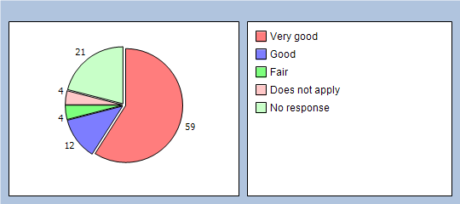
Q28 Involving you in decisions about your care
Very good 43%
Good 19%
Fair 4%
Poor 0%
Very poor 0%
Does not apply 12%
No response 22%
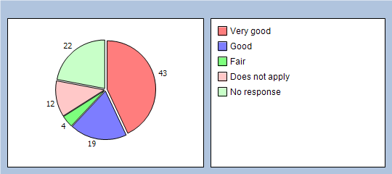
Q29 Treating you with care and concern
Very good 64%
Good 12%
Fair 3%
Poor 0%
Very poor 0%
Does not apply 1%
No response 20%
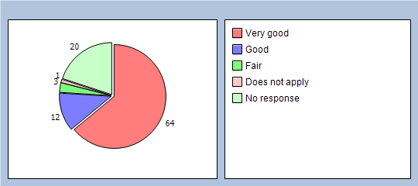
Q30 Did you have confidence and trust in the nurse you saw or spoke to?
Yes, definitely 70%
Yes, to some extent 8%
No, not at all 0%
Don’t know / can’t say 1%
No response 21%
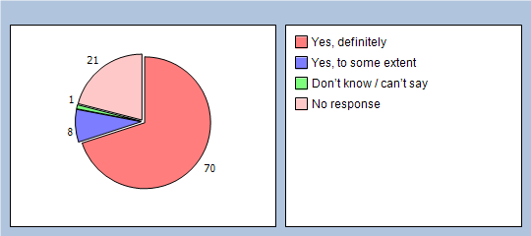
If you know the name of the nurse you last saw, please write it here:

About care from your doctors and nurses

Thinking about the care you get from your doctors and nurses overall, how well does the practice help you to:
Q31 Understand your health problems?
Very well 80%
Unsure 14%
Not very well 1%
Does not apply 0%
No response 5%
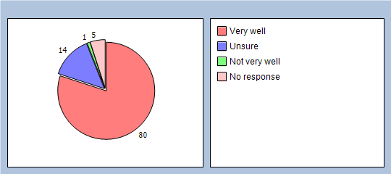
Q32 Cope with your health problems
Very well 82%
Unsure 11%
Not very well 3%
Does not apply 0%
No response 4%
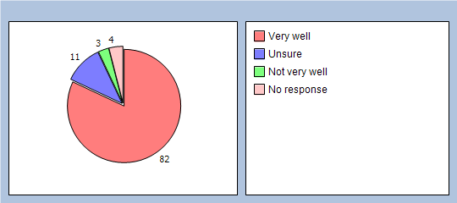
Q33 Keep yourself healthy
Very well 64%
Unsure 19%
Not very well 3%
Does not apply 8%
No response 6%
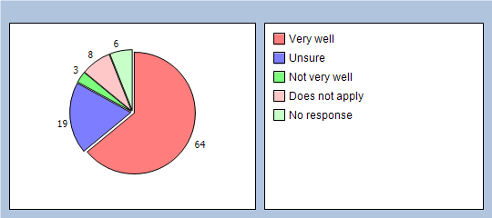
Q34 Overall, how would you describe your experience of your GP surgery?
Excellent 58%
Very good 27%
Good 4%
Fair 8%
Poor 0%
Very poor 0%
No response 3%
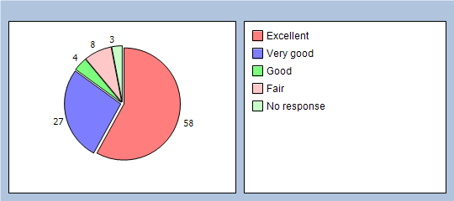
Q35 Would you recommend your GP surgery to someone who has just moved to your local area?
Yes, definitely 77%
Yes, probably 9%
No, probably not 6%
No, definitely not 0%
Don’t know 3%
No response 5%
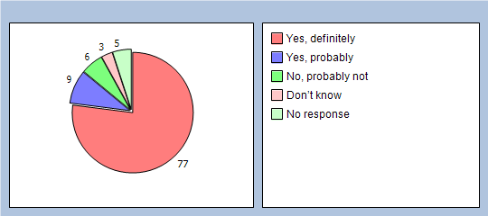

It will help us to understand your answers if you could tell us a little about yourself
Q36 Are you?
Male 51%
Female 48%
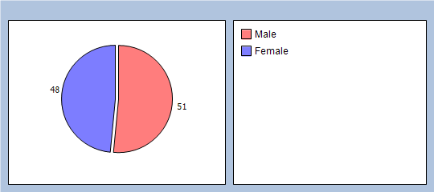
Q37 How old are you?
Under 16 1%
16 to 44 20%
45 to 64 30%
65 to 74 25%
75 or over 20%
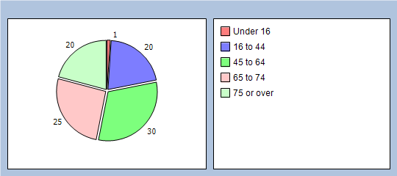
Q38 Do you have a long-standing health condition?
Yes 53%
No 40%
Don’t know / can’t say 6%
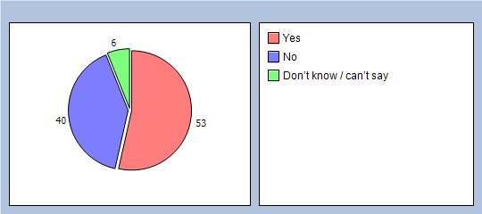
Q39 What is your ethnic group?
White 100%
Black or Black British 0%
Asian or Asian British 0%
Mixed 0%
Chinese 0%
Other ethnic group 0%
Q40 Which of the following best describes you?
Employed (full or part time, including self-employed) 20%
Unemployed / looking for work 3%
At school or in full time education 1%
Unable to work due to long term sickness 3%
Looking after your home/family 6%
Retired from paid work 59%
Other 4%
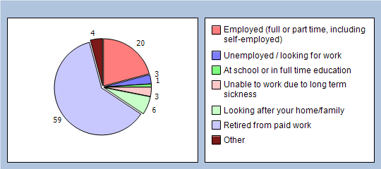
Finally, please add any other comments you would like to make about your GP practice:
© 2011 GPAQ V3 including all individual questions is copyright University of Cambridge/University of Manchester

